|  |  |  |  |
| --- | --- | --- | --- |
| **paf_kiet_logo** | **COLLEGE OF COMPUTING AND INFORMATION SCIENCES** | | |
| **Final Assessment of Lab Exam (Fall 2020 Semester)** | | |
| **Class Id** | 105127 | **Course Title** | Numerical Computing |
| **Program** | BSCS | **Campus / Shift** | North/ Morning |
| **Date** | November 26, 2020 | **Total Marks** | 20 |
| **Duration** | 03 hours | **Faculty Name** | Iqra Fahad |
| **Student Id** | 63961 | **Student Name** | Ali Afzal |
| **Code** | **A** |  |  |

**Instructions:**

* Fill out your Student ID and Student Name in above header.
* Do not remove or change any part question paper.
* Write down your answers with title “Answer for Question# 00”.
* Handwritten text or image should be on A4 size page with clear visibility of contents.
* In case of CHEATING, COPIED material or any unfair means would result in negative marking or ZERO.
* Viva can be taken with prior notice, where deemed necessary.
* **Caution:** Duration to perform Final Assessment is **02 hours only and 01 hour** is given to cater all kinds of odds in submission of Answer-sheet. **Therefore, if you failed to upload answer sheet on LMS (in PDF format) within 3 hours’ limit, you would be considered as ABSENT/FAILED.**

**Question 01:**

 The number of bacteria measured at different times t is given in the following table. Determine a

function that best fits the data (built-in function allowed). Use the equation to estimate the number of bacteria after 5h (built-in function not allowed). Make a plot of the points and the equation.

https://lh5.googleusercontent.com/uCS4IDGySuXCFb2sGnm8iIkK1Ru2w_fChcgb21wGp-Her8EruiFZpriFKoesOlfEqIyZLb9UQnX1IcxJ-P-anNkv29RV2bwrP6bLWrD8WyNExaPeg_cFzjhIhD1-Rj2ATdiMRuw

**Answer 01:**

import matplotlib.pyplot as plt

from scipy.interpolate import lagrange

def proterm(i, value, x):

pro = 1

for j in range(i):

pro = pro \* (value - x[j])

return pro

def dividedDiffTable(x, y, n):

for i in range(1, n):

for j in range(n - i):

y[j][i] = ((y[j][i - 1] - y[j + 1][i - 1])/(x[j] - x[i + j]))

return y

def applyFormula(value, x, y, n):

sum = y[0][0]

for i in range(1, n):

sum = sum + (proterm(i, value, x) \* y[0][i])

return sum

n = 7

y = [[0 for i in range(7)] for j in range(7)]

x = [ 0, 1, 3, 4, 6, 7, 9]

y[0][0] = 500

y[1][0] = 600

y[2][0] = 1000

y[3][0] = 1400

y[4][0] = 2100

y[5][0] = 2700

y[6][0] = 4100

y=dividedDiffTable(x, y, n)

value = 5

print("\nValue at", value, "is", round(applyFormula(value, x, y, n), 2))

print("\n\nRequired Equation is :")

print(lagrange(x,y))

print("\n\n")

ploty=[]

for i in range(7):

ploty.append(y[i][0])

plt.plot(x,ploty,color='k', marker='D',linestyle='--', linewidth=2)

plt.grid()

plt.show()

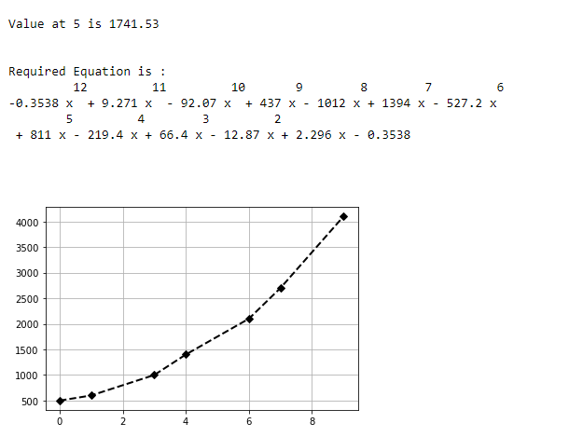

**Question 02**

A dietitian wishes to plan a meal around three foods. The percentage of the daily requirements of proteins, carbohydrates, and iron contained in each ounce of the three foods is summarized in the following table:

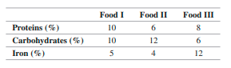

Determine (using Python code) how many ounces of each food the dietitian should include in the meal to meet exactly the daily requirement of proteins, carbohydrates, and iron (100% of each).

**Answer 02:**

import numpy as np

n = 3

a = np.zeros((3,4))

x = np.zeros(3)

a[0][0]=10

a[0][1]=6

a[0][2]=8

a[0][3]=100

a[1][0]=10

a[1][1]=12

a[1][2]=6

a[1][3]=100

a[2][0]=5

a[2][1]=4

a[2][2]=12

a[2][3]=100

for i in range(n):

for j in range(i+1, n):

ratio = a[j][i]/a[i][i]

for k in range(n+1):

a[j][k] = a[j][k] - ratio \* a[i][k]

x[n-1] = a[n-1][n]/a[n-1][n-1]

for i in range(n-2,-1,-1):

x[i] = a[i][n]

for j in range(i+1,n):

x[i] = x[i] - a[i][j]\*x[j]

x[i] = x[i]/a[i][i]

print("Food I in ounces = ",x[0])

print("Food II in ounces = ",x[1])

print("Food III in ounces = ",x[2])

Screenshot (238)